Ratnasingam Ratnasekar
Contact no: +94 77 67 88 925
Email: mayurancs@gmail.com

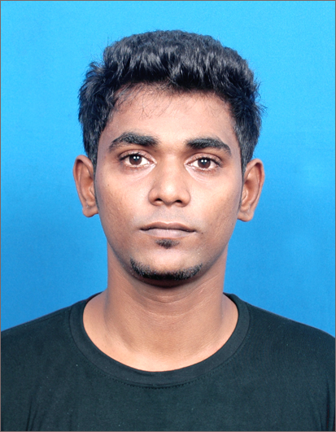
Personal Details

Full Name : Ratnasingam Ratnasekar
Address : 129/35 Ginthupitiya Street. Colombo-13
Date of Birth : 21st April 1992
N.I.C No. : 921124503 V
Gender : Male
Nationality : Sri Lankan
Marital Status : Single
Languages Known : English, Tamil

Educational Qualifications

G.C.E (Ordinary Level) December 2009

Examination Body : Department of Examinations, Sri Lanka
Subjects : Commerce - S
Mathematics - W
English Language - S
Tamil - S
Religion - C
Health - C
Science - S
Music - W

School : Colombo Central Hindu Maha Vidhyalaya

Foundation Certificate in International Higher Diploma (IHD) 2010

Currently doing the Final year of IHD in Software Development at IDM City Campus Kotahena

Certificate Course in Software Development in Java 2015

Certificate in Software Development in JAVA at NIBM Sri Lanka

Other Qualifications

Computer skills in : Ms Package
Java
VB.Net Basic
C# Basic
Mysql Database
Html Basic

Non- related Referees
Thisara Weerasinghe (BSc.MIS(Ireland),MSc.IT(Moratuwa),MBCS)
Consultant,
National Institute of Business Management
Colombo 7.
Mobile:0773928164
Office :011-5321000/108
Skype :thisaratsp1

I do hereby certify that the above particulars furnished by me are true & accurate to the best of my knowledge & belief.

Ratnasingam Ratnasekar

